**Submission Instructions:**

Your submission for this project should be a Word document that includes the following screenshots, each labeled for the step that the screenshot represents:

1. Provide a screenshot to show that you created the alarm field inside your Realtime database and initialized it to zero.

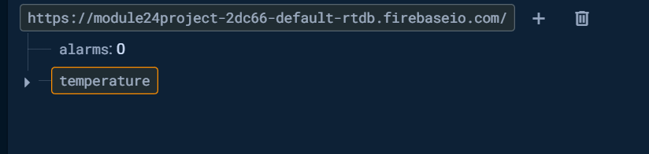

1. Provide a screenshot to show that you created the CreateAndClear*Alarms* rule chain with all of the necessary components.

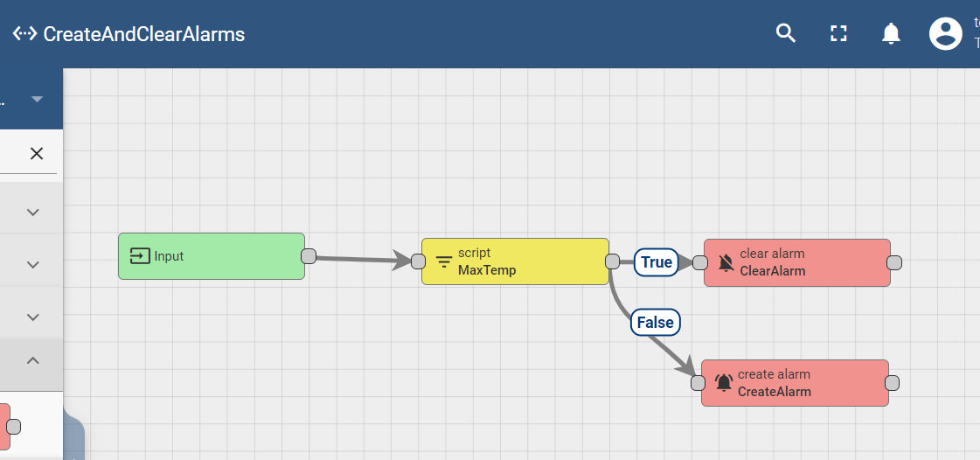

1. Provide a screenshot to show that you created the TempToFirebase rule chain with all of the necessary components.

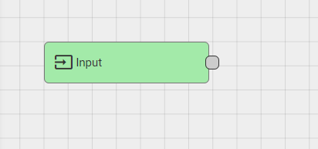

1. Provide two screenshots. The first screenshot should show that you added the TempToFirebase *node* to your Rule Engine correctly. The second screenshot should show that you connected the Input and TempToFirebase *nodes*.

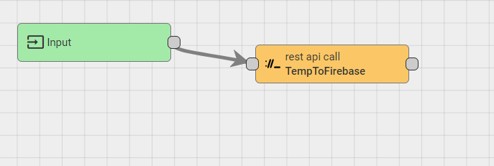

1. Provide a screenshot to show that you created the *Alarm*ToFirebase rule chain with all of the necessary components.

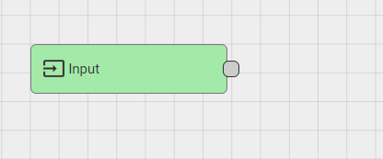

1. Provide two screenshots. The first screenshot should show that you added the *Alarm*ToFirebase *node* to your Rule Engine correctly. The second screenshot should show that you connected the Input and *Alarm*ToFirebase *nodes*.

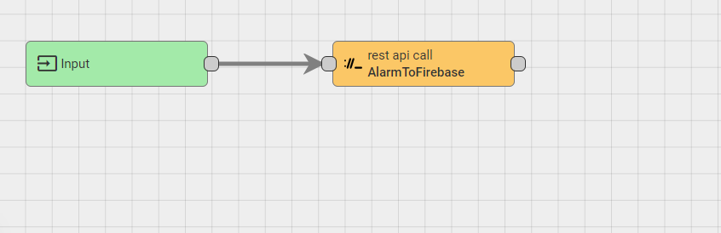

1. Provide a screenshot to show that you added the *Alarm*ToFirebase *node* to your Rule Engine correctly.

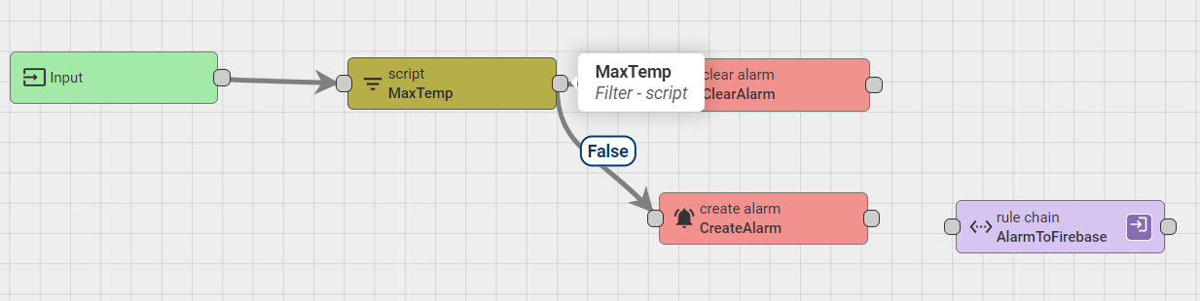

1. Provide a screenshot to show that you connected the Create*Alarm* and *Alarm*ToFirebase *nodes* with a Created link label.

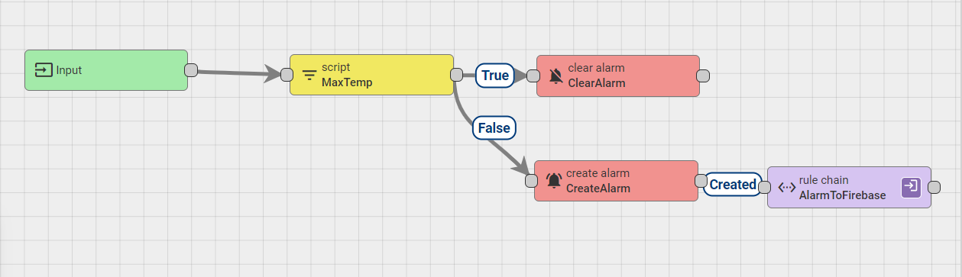

1. Provide a screenshot to show that you added the TempToFirebase *node* to your Rule Engine correctly.

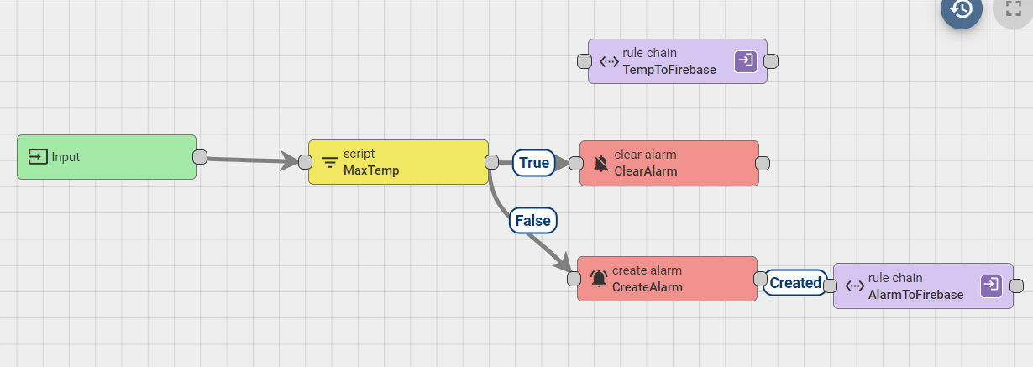

1. Provide a screenshot to show that you connected the MaxTemp and *Alarm*ToFirebase *nodes* with a True link label.

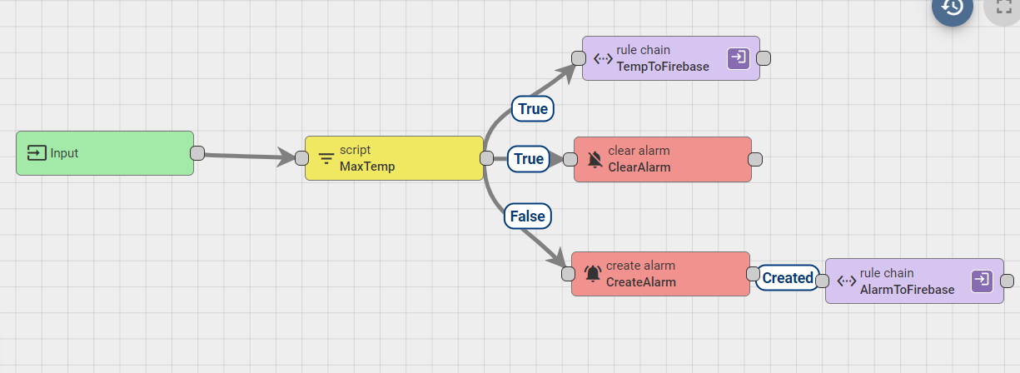

1. Provide a screenshot to show that you added the CreateAndClear*Alarm* *node* to your Rule Engine correctly.

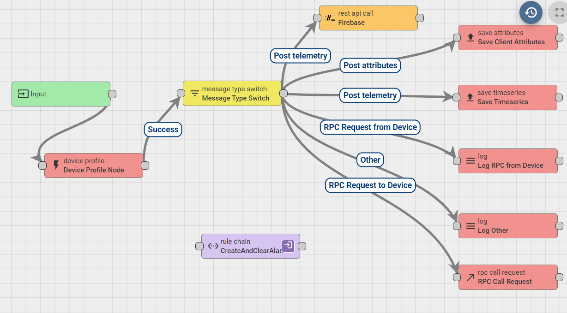

1. Provide a screenshot to show that you connected the SaveTimeseries and CreateAndClear*Alarm nodes* with a Success link label.

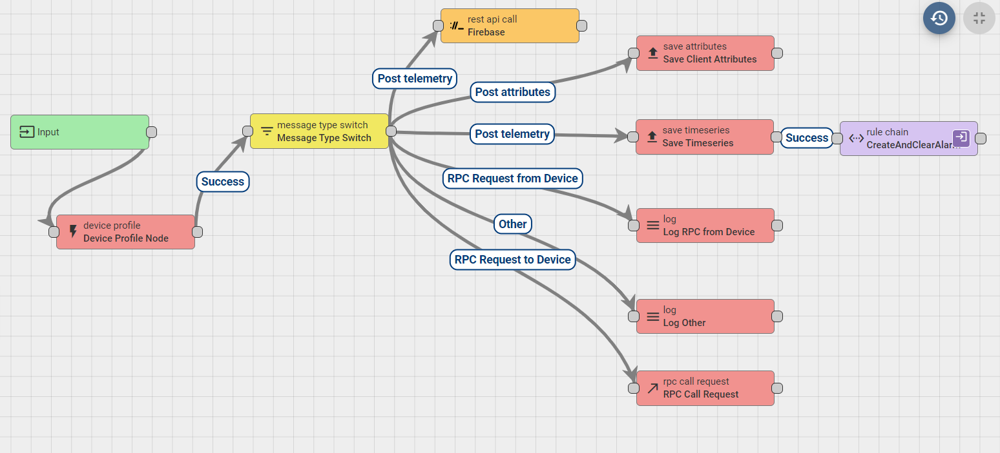

1. Provide two screenshots. The first screenshot should show that the alarm field is being populated with the live *streaming* data from the CreateAndClear*Alarm* rule chain. The second screenshot should show that the temperature field is being populated with temperature and humidity data.

